Viscosity project report 27 Feb 2023

**Part 1: Human**

Anne Qian

**Objectives and overview**

This project aims to create a model of multilinear regression that finds optimised parameters for the transfer of fluids of different viscosities using the Opentrons machine. The Opentrons OT-2 liquid handler machine is capable of automating simple yet time-consuming tasks, such as serial dilution. However, it is not suited for liquids of high viscosity like organic solvents used in Chemistry experiments. The development of this model will greatly increase the machine’s application in chemical research and development.

This project has 2 main parts. The first part of this project is partially automated, meaning the protocols are executed by Opentrons but humans supervise and suggest changes in parameters for each iteration. This report analyses and concludes the first part of this project.

The second part of this project will focus on “training” the machine to suggest parameters to be executed based on data collected from the first part of the project. The amount of data provided will be varied to examine its impact on the accuracy of the parameters.

**Methodology**

Mineral oils of known viscosity levels are set as independent variables and a rough estimation of the standard’s aspiration rate is determined by visual inspection (sample is aspirated from the vial, time taken for the pipette to aspirate 1000 uL is recorded, one can calculate the aspiration rate)

The amount of liquid transferred by pipetting will be validated by measuring the transferred mass for each viscosity standard. Next, the parameters will be changed accordingly to ensure the percentage error remains within ±2% when transferring 1000/500/300 uL of viscous liquid from original vial to destination vial. To ensure the reliability of the results, each volume iteration will be repeated for 3 times.

There are no fixed methodologies to change the parameters but 2 objectives must be met: 1) percentage error stays within ±2%; 2) minimise time taken for the transfer of samples.

**Samples:**

| Viscosity standards (cP) at 25°C | Density (g/cm3) at 25°C |
| --- | --- |
| 3.320 | 0.8181 |
| 28.53 | 0.8470 |
| 99.85 | 0.8578 |
| 204.8 | 0.8639 |
| 398.4 | 0.8672 |
| 505.4 | 0.8683 |
| 817.4 | 0.8466 |
| 1275 | 0.8736 |
| 4806 | 0.8802 |
| 5882 | 0.8819 |
| 6695 | 0.8726 |
| 7782 | 0.8826 |
| 9884 | 0.8844 |

**Parameters:**

* Aspiration rate
* Dispense rate
* Aspiration delay
* Dispense delay
* Blow out rate
* Blow out delay

Touchtip_aspiration set to True but Touchtip_dispense set to False

Rationale: It is okay to use Touch Tip when liquid is being aspirated as it will not be included in the reaction mixture - excess left in source vial. Touchtip_dispense not used as liquid will be left on the rim of the destination vial, so it contributes to the mass of the final vial but will not be involved in the reaction or used.

**Results**

Average time taken for each standard

| **Viscosity standards (cP)** | **Average duration (1000uL)** | **Average duration (500uL)** | **Average duration (300uL)** |
| --- | --- | --- | --- |
| 7782 | 1141.67201 | 587.753470 | 506.556783 |
| 6695 | 973.124254 | 515.136350 | 328.351349 |
| 5882 | 772.466932 | 412.181146 | 261.268469 |
| 4801 | 698.724213 | 369.857342 | 229.736197 |
| 1275 | 495.157667 | 255.343295 | 159.190117 |
| 817.0 | 196.173286 | 106.328671 | 70.5005945 |
| 505.4 | 86.0979237 | 62.1219080 | 53.7858717 |
| 398.4 | 77.9755910 | 57.9199131 | 50.3105131 |
| 204.8 | 62.6949278 | 47.8901531 | 41.8450938 |
| 99.85 | 27.8680814 | 19.6189684 | 16.0926191 |
| 28.53 | 19.3615166 | 11.4208848 | 8.90326770 |
| 3.320 | 17.0286927 | 14.5164381 | 12.2697430 |

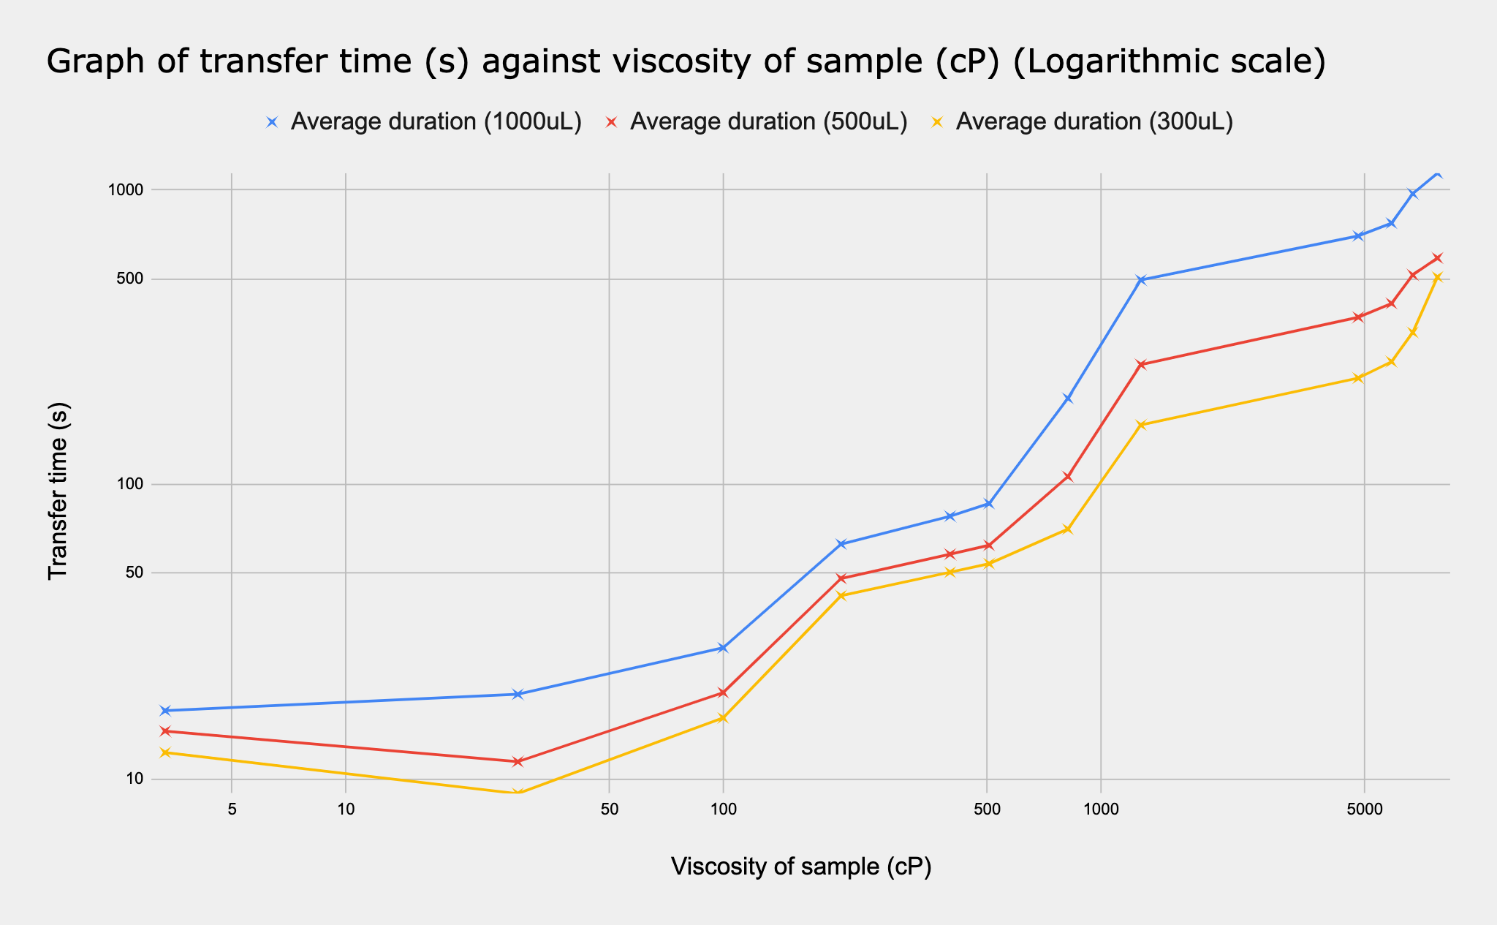

| Standard: 3.320 cP | |
| --- | --- |
|  | **Final parameters:**  Aspiration rate: 175  Dispense rate: 175  Aspiration delay: 2  Dispense delay: 2  Blowout rate: 0  Blowout delay: 0 |

| Standard: 28.53 cP | |
| --- | --- |
|  | **Final parameters:**  Aspiration rate: 155  Dispense rate: 155  Aspiration delay: 2  Dispense delay: 0  Blowout rate: 0  Blowout delay: 0 |

| Standard: 99.85 cP | |
| --- | --- |
|  | **Final parameters:**  Aspiration rate: 120  Dispense rate: 120  Aspiration delay: 5  Dispense delay: 1  Blowout rate: 0  Blowout delay: 0 |

| Standard: 204.8 cP | |
| --- | --- |
|  | **Final parameters:**  Aspiration rate: 70  Dispense rate: 70  Aspiration delay: 0.5  Dispense delay: 0  Blowout rate: 5  Blowout delay: 0 |

**Analysis and comments** [3-200 cP standards]

The readings are relatively more volatile than standards of higher viscosity: changing the parameters by 0.1/0.2 can have a big impact on volume transferred. On average, more trials needed for standards of lower viscosity but much quicker.

Blowout rate in general is not needed for standards of very low viscosity as complete dispense is achieved easily. Try to minimise dispense delay for the same reason aforementioned, to be more time efficient.

Just a thought: There are many ways to achieve the same effect (to increase volume transferred, one can decrease aspiration rate, increase blow out rate, etc), but due to time constraints, it is not possible to try all iterations, AI might be able to run virtual simulations of all possibilities under much shorter time.

| Standard: 398.4 cP | |
| --- | --- |
|  | **Final parameters:**  Aspiration rate: 53  Dispense rate: 53  Aspiration delay: 2.83  Dispense delay: 3  Blowout rate: 5  Blowout delay: 0 |

| Standard: 505.4 cP | |
| --- | --- |
|  | **Final parameters:**  Aspiration rate: 41  Dispense rate: 43  Aspiration delay: 4  Dispense delay: 2.5  Blowout rate: 5  Blowout delay: 0 |

| Standard: 817 cP | |
| --- | --- |
|  | **Final parameters:**  Aspiration rate: 20  Dispense rate: 8  Aspiration delay: 5  Dispense delay: 5  Blowout rate: 0  Blowout delay: 0 |

**Analysis and comments** [300-800 cP standards]

Blowout rate is required for most standards as complete dispense is achieved much harder at 300-800 cP. However, continue to minimise dispense delay for the same reason aforementioned, to be more time efficient.

A common problem observed for most standards between this viscosity range is that dispense delay/blowout rate causes a cluster of small bubbles to form at the pipette tip (outside) but dispense delay/blowout rate is crucial for complete dispense of sample.

However, this problem is not relevant to viscosity standards that are very high or very low. This problem created discrepancies for volume transferred even when the parameters are kept constant. This affects the consistency of results obtained. The cluster of bubbles sometimes drops in the destination vial but sometimes is returned back to the original vial. One might suggest using Touchtip function after dispensing but it is not used for rationale provided in the parameters section.

| Standard: 1275 cP | |
| --- | --- |
|  | **Final parameters:**  Aspiration rate: 9  Dispense rate: 3  Aspiration delay: 3  Dispense delay: 3  Blowout rate: 0  Blowout delay: 0 |

| Standard: 4801 cP | |
| --- | --- |
|  | **Final parameters:**  Aspiration rate: 3.75  Dispense rate: 3.5  Aspiration delay: 6  Dispense delay: 5  Blowout rate: 5  Blowout delay: 0 |

| Standard: 5882 cP | |
| --- | --- |
|  | **Final parameters:**  Aspiration rate: 2.5  Dispense rate: 3  Aspiration delay: 5  Dispense delay: 3  Blowout rate: 5  Blowout delay: 0 |

| Standard: 6695 cP | |
| --- | --- |
|  | **Final parameters:**  Aspiration rate: 2.1  Dispense rate: 3  Aspiration delay: 5  Dispense delay: 3  Blowout rate: 5  Blowout delay: 0 |

| Standard: 7782 cP | |
| --- | --- |
|  | **Final parameters:**  Aspiration rate: 1.35  Dispense rate: 3  Aspiration delay: 5  Dispense delay: 5  Blowout rate: 5  Blowout delay: 0 |

| Standard: 9884 cP | |
| --- | --- |
|  | **Final parameters:**  Aspiration rate: 2  Dispense rate: 0.5  Aspiration delay: 3  Dispense delay: 3  Blowout rate: 4  Blowout delay: 3 |

**Analysis and comments** [4000-9000 cP standards]

For high viscosity standards, the speed at which the pipette tip is lifted up from the original vial should be decreased to reduce the amount of liquid clinging onto the sides of the pipette tip, or the extent to which the pipette tip is lowered/submerged in the vial should be reduced (currently 15mm).

The added mass of liquid on the outer walls of the pipette tip is transferred to the destination vial and slowly drips down while the machine is dispensing.

At extremely high viscosity, the liquid coated on the outer wall of the pipette does not affect the volume transferred that much. Without enough pressure pushing it down, it just stays on the wall, negligible effect on the volume transferred.

An interesting pattern observed is that when a clean pipette is used, the first reading will be inaccurate, usually around 11 - 12%. However, it will work after the inner walls are coated with the standards’ residue. Thus, it is advisable to have a ‘preparation’ step before liquid transfer - one can aspirate 1000uL and dispense back to the original vial to ‘rinse’ the clean pipette with the standard. This is only observed for higher viscosity from 1275 cP, very low viscosity standards 3-100 cP does not need preparation step.

This pattern is checked with viscosity 1275cP (Trial 1: -4.37%, Trial 2: -0.601%), 4801cP (Trial 1: -12.8%, Trial 2: -0.886%), 5582cP (Trial 1: -13.8%, Trial 2: -0.725%), 6695cP (Trial 1: -12.2%, Trial 2: -0.550%) and 7782cP (Trial 1: -10.4%, Trial 2: -%)

Relationship between each parameter and different standards

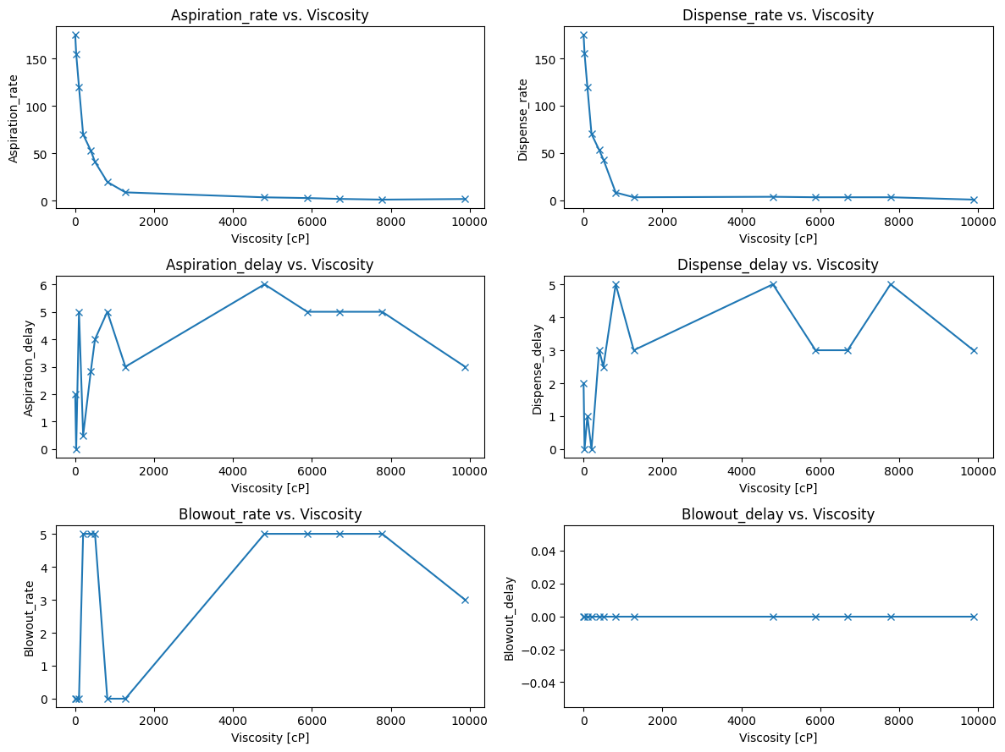

Parameters of iterations: standard 3.320 cP

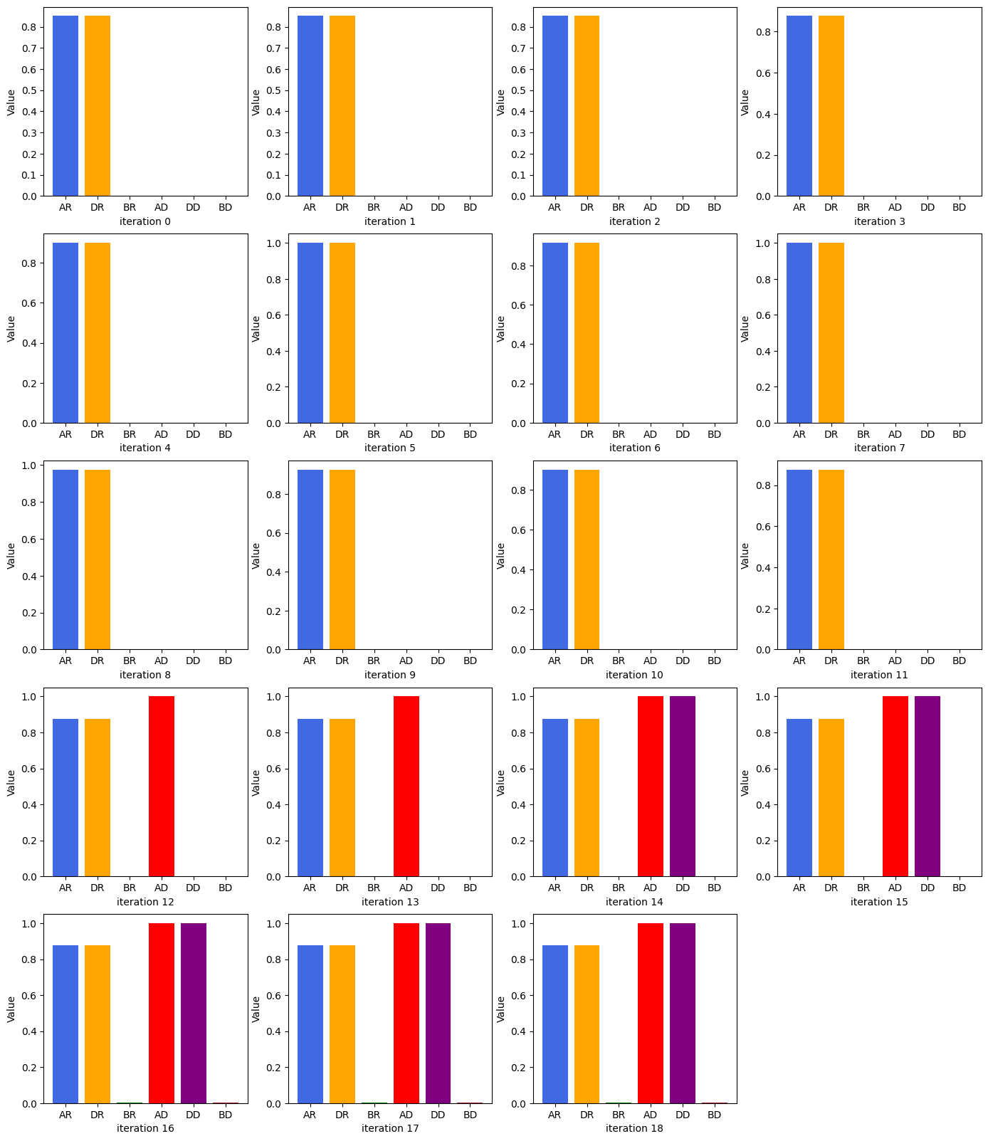

Parameters of iterations: standard 28.53 cP

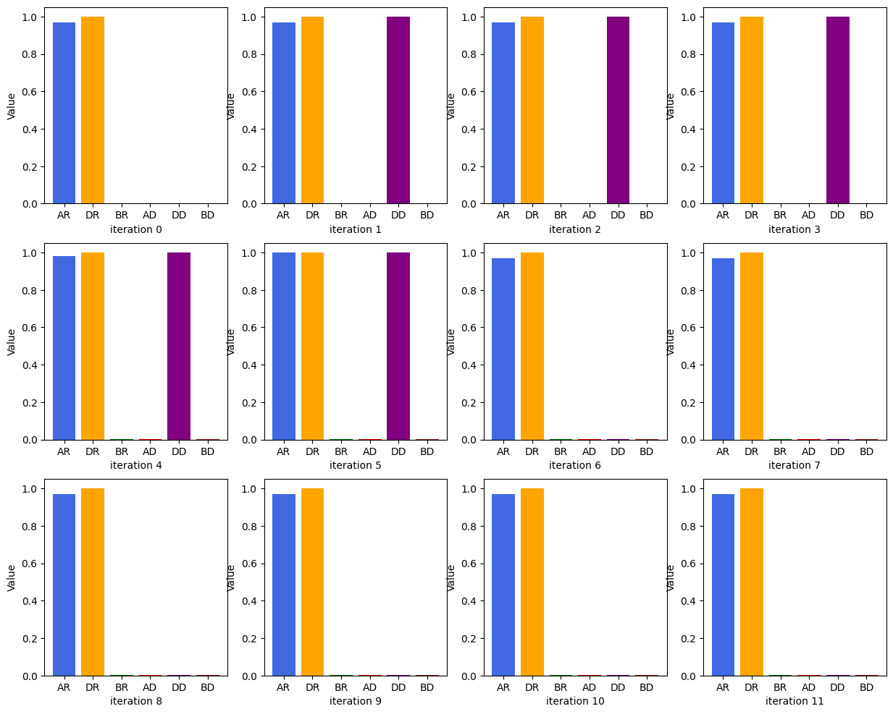

Parameters of iterations: standard 99.85 cP

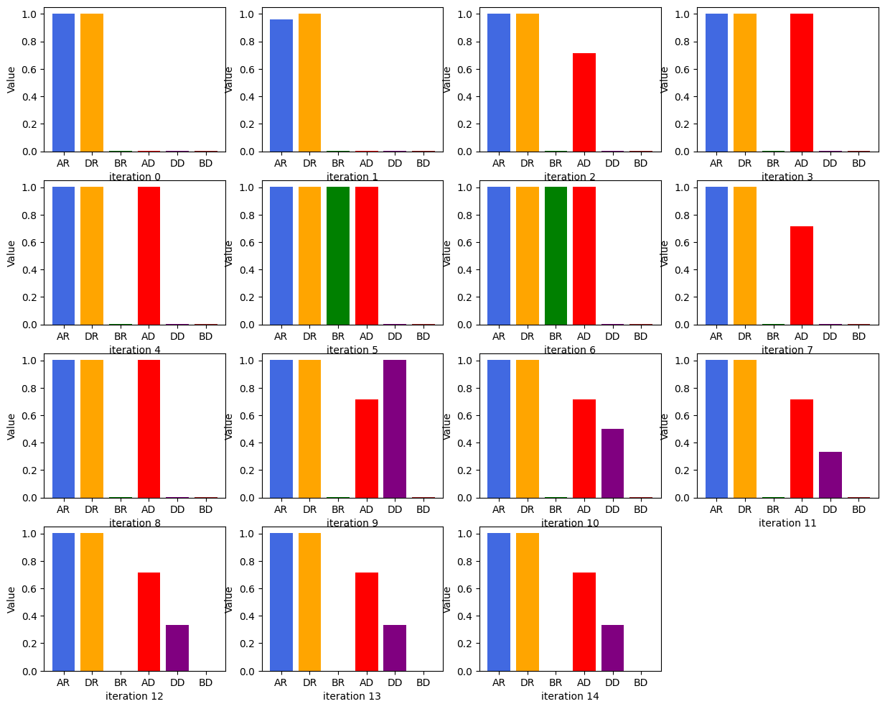

Parameters of iterations: standard 204.8 cP

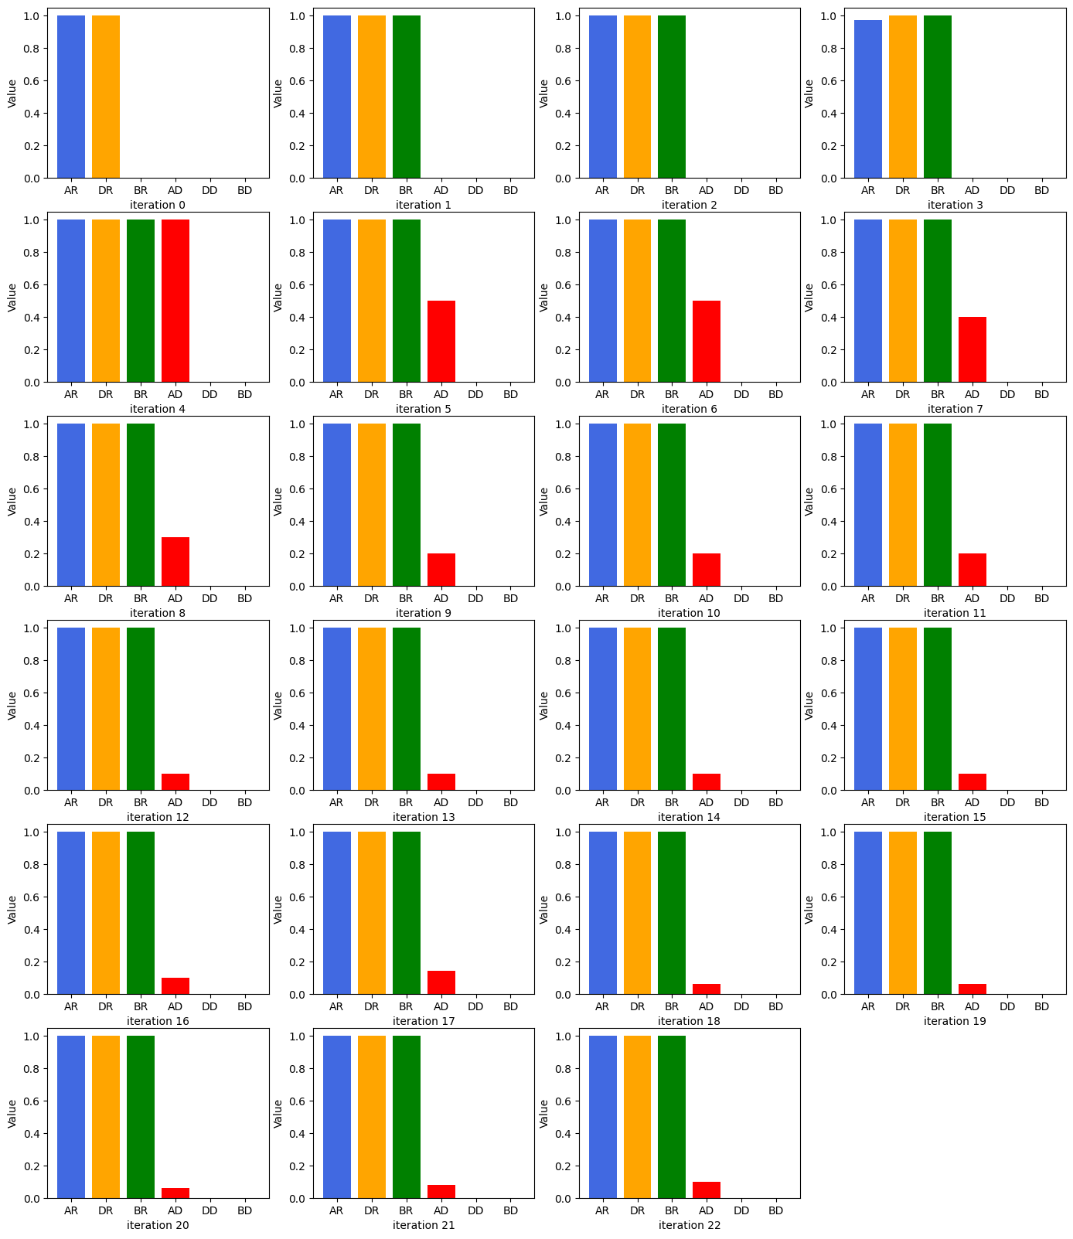

Parameters of iterations: standard 398.4 cP

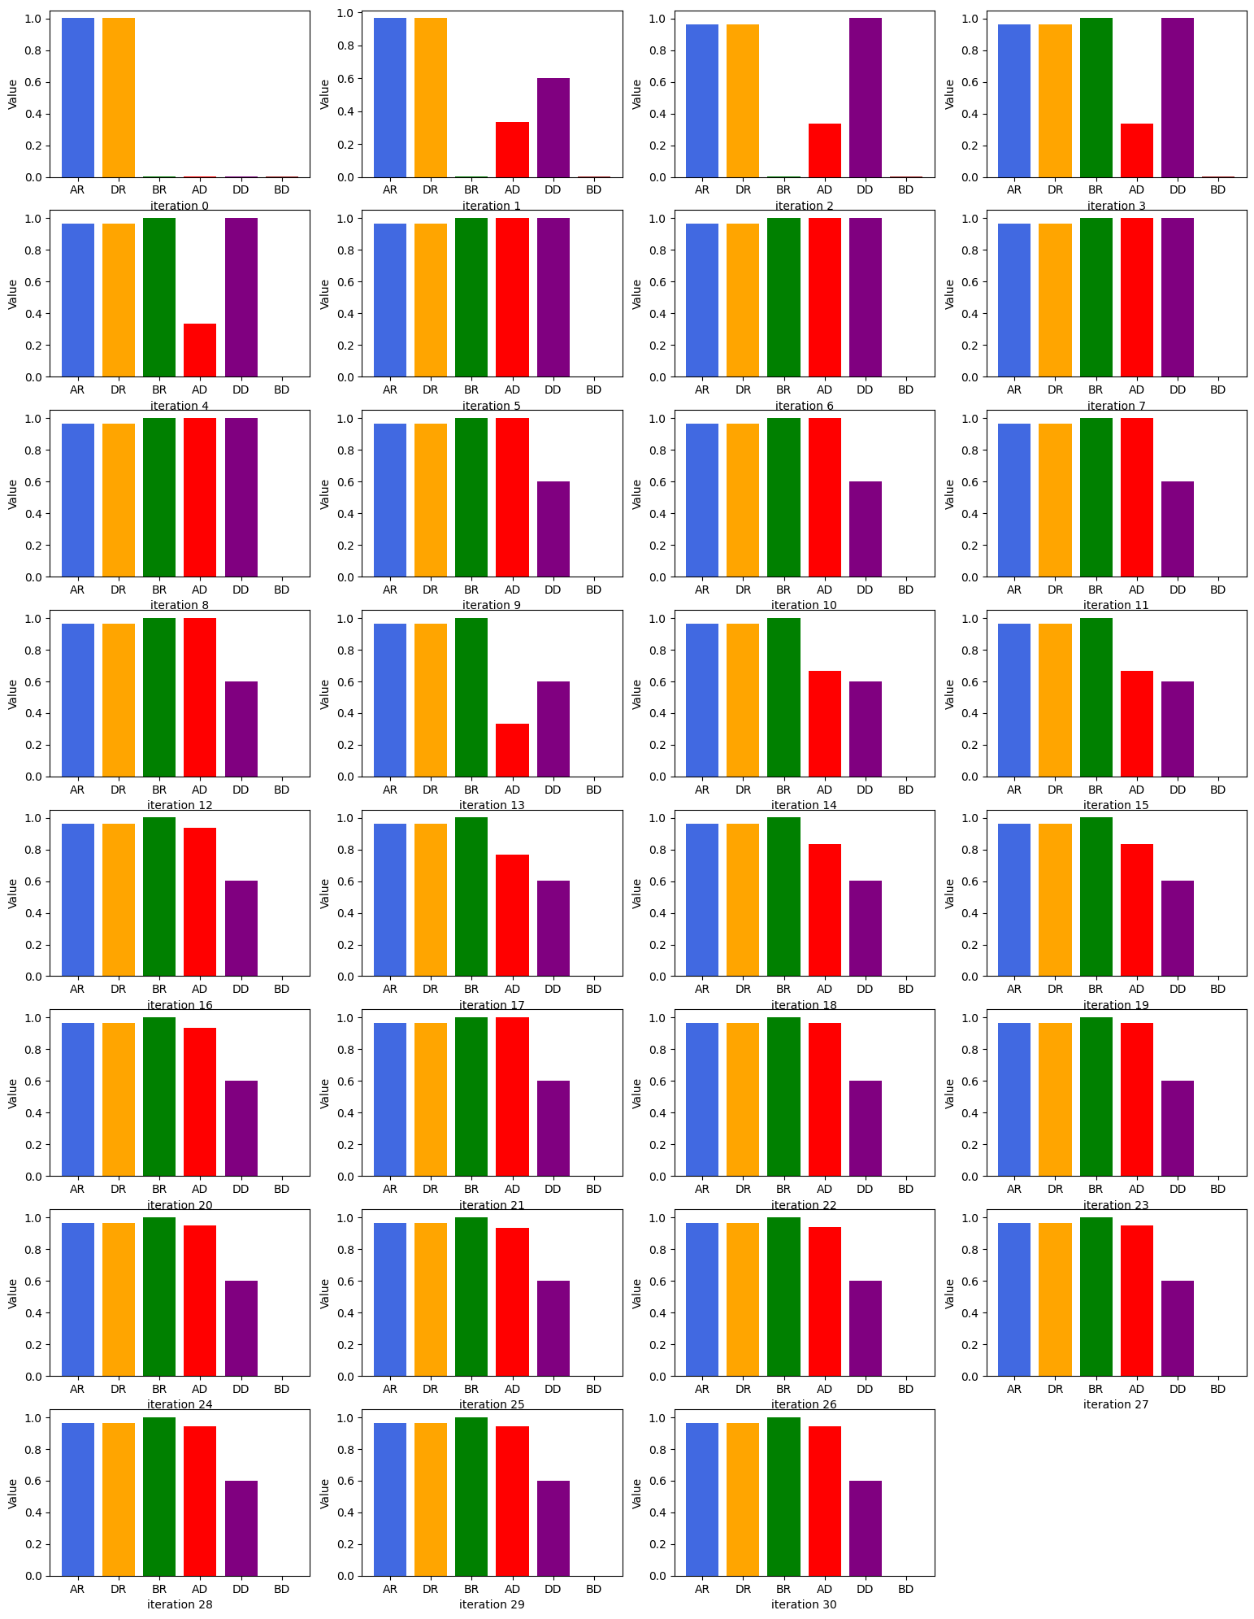

Parameters of iterations: standard 505.4 cP

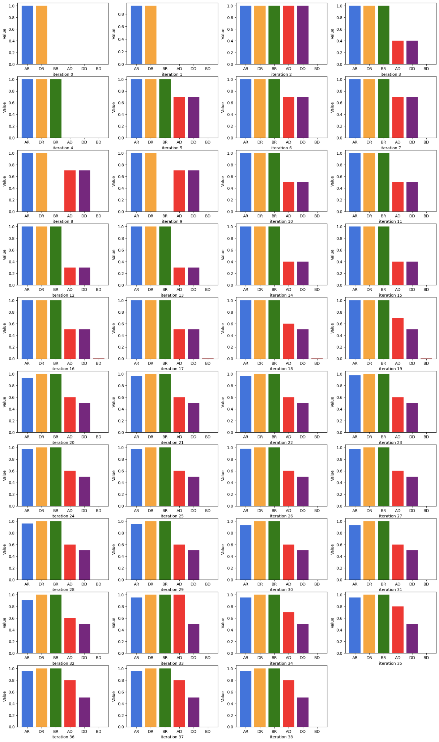

Parameters of iterations: standard 817.4 cP

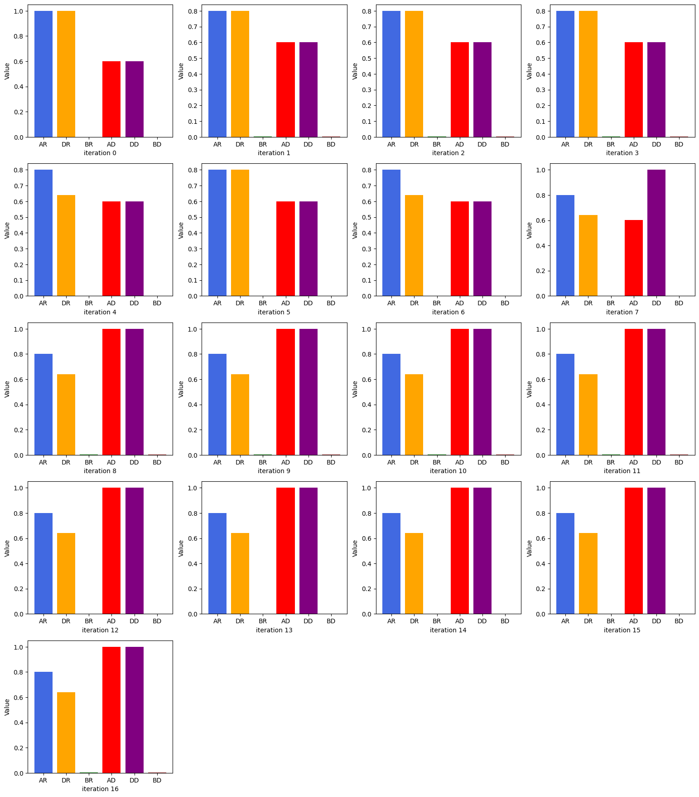

Parameters of iterations: standard 1275 cP

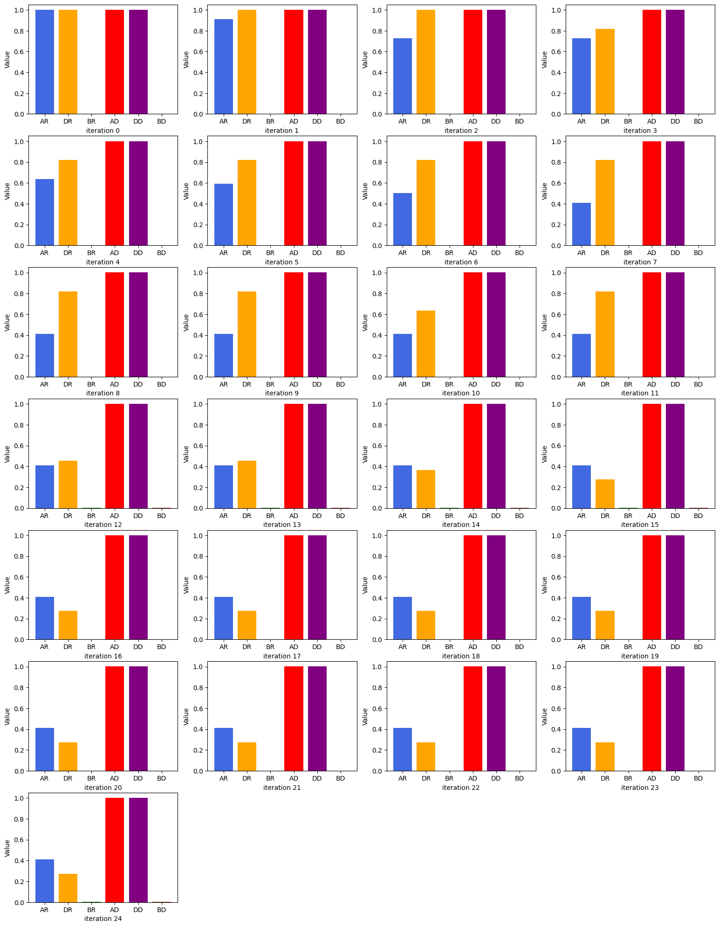

Parameters of iterations: standard 4801 cP

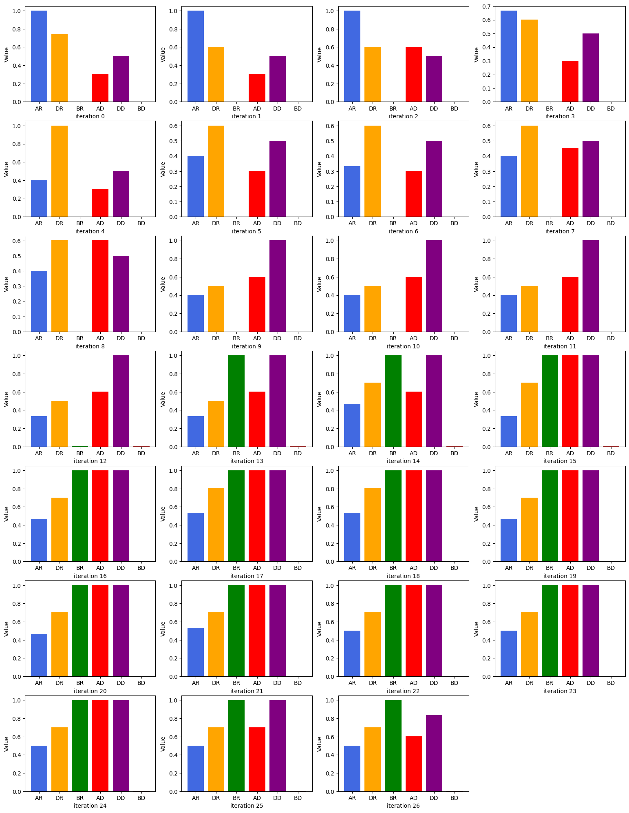

Parameters of iterations: standard 5882 cP

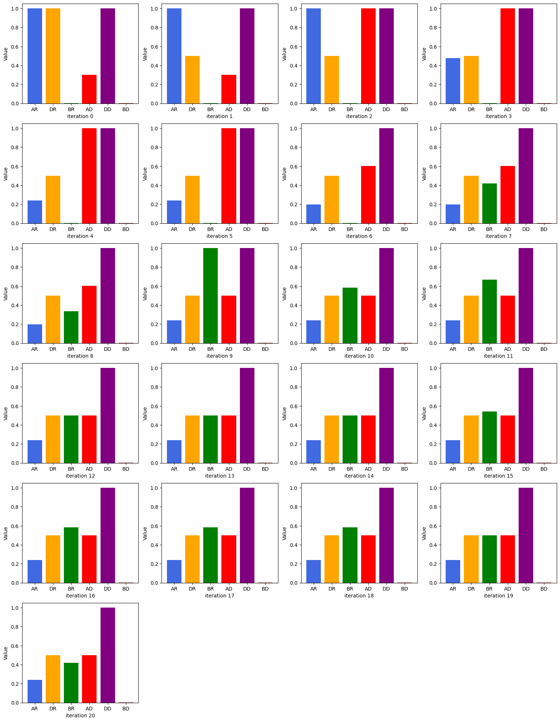

Parameters of iterations: standard 6695 cP

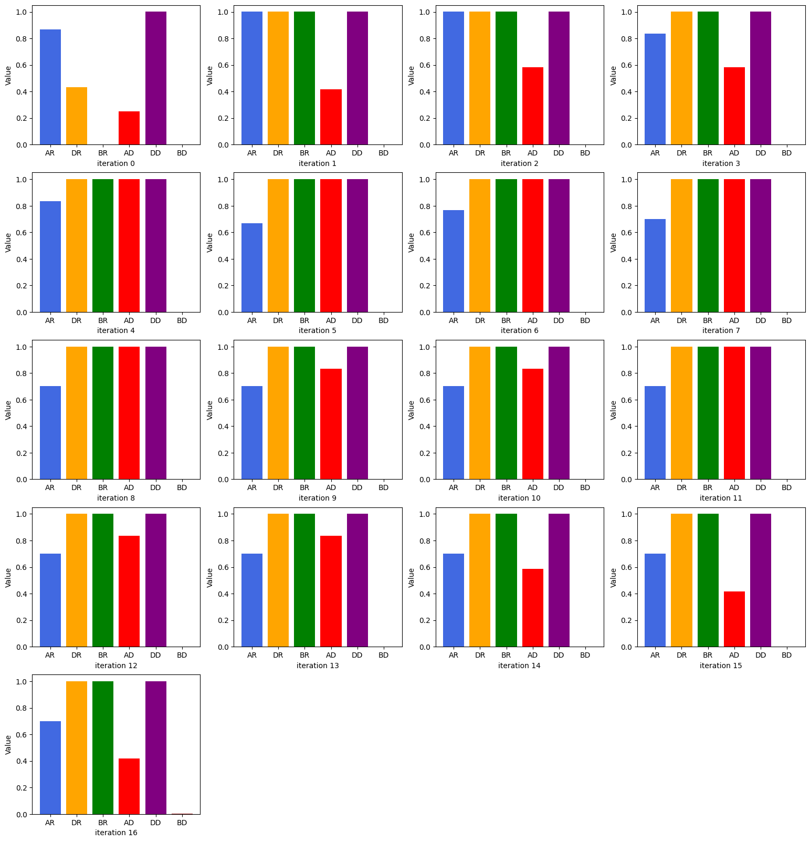

Parameters of iterations: standard 7782 cP

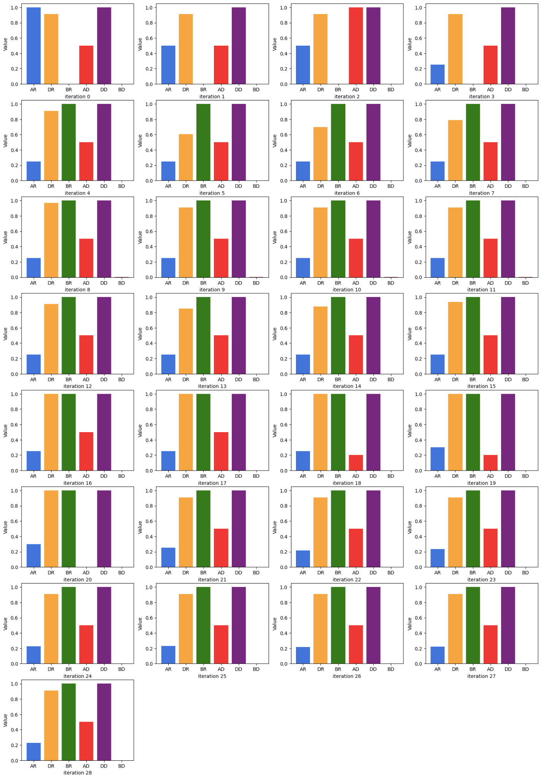

Parameters of iterations: standard 9884 cP

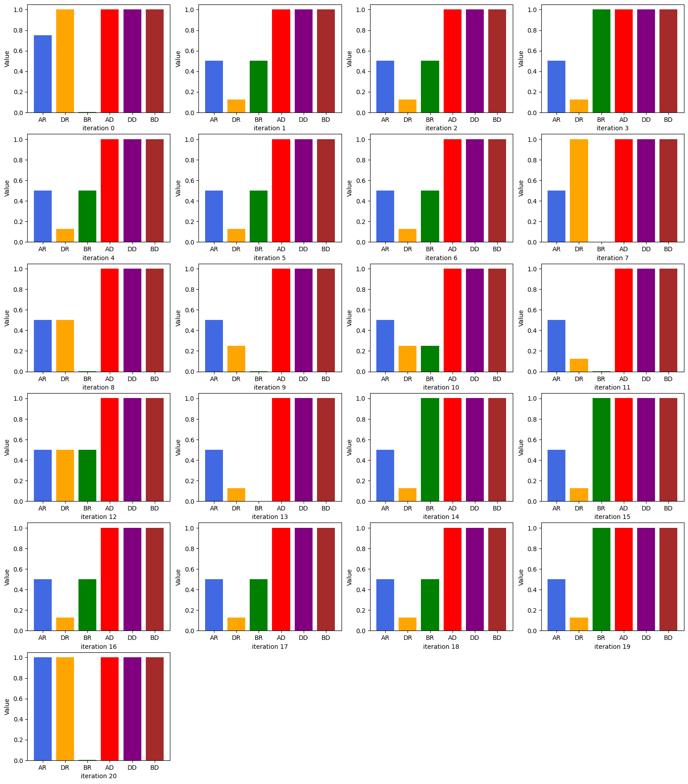

Conclusion

This report marks the end of the human segment of the Opentrons viscosity project and the second segment will utilise Visual Studio code and Spyder. After comparing the data, I realised that the delay blow out parameter is not used for most of the standards and its effect should be investigated for future liquid transfer trials.

Other factors, such as volatility and vapour pressure of the sample should be considered to obtain a more all rounded picture and create a more accurate model.